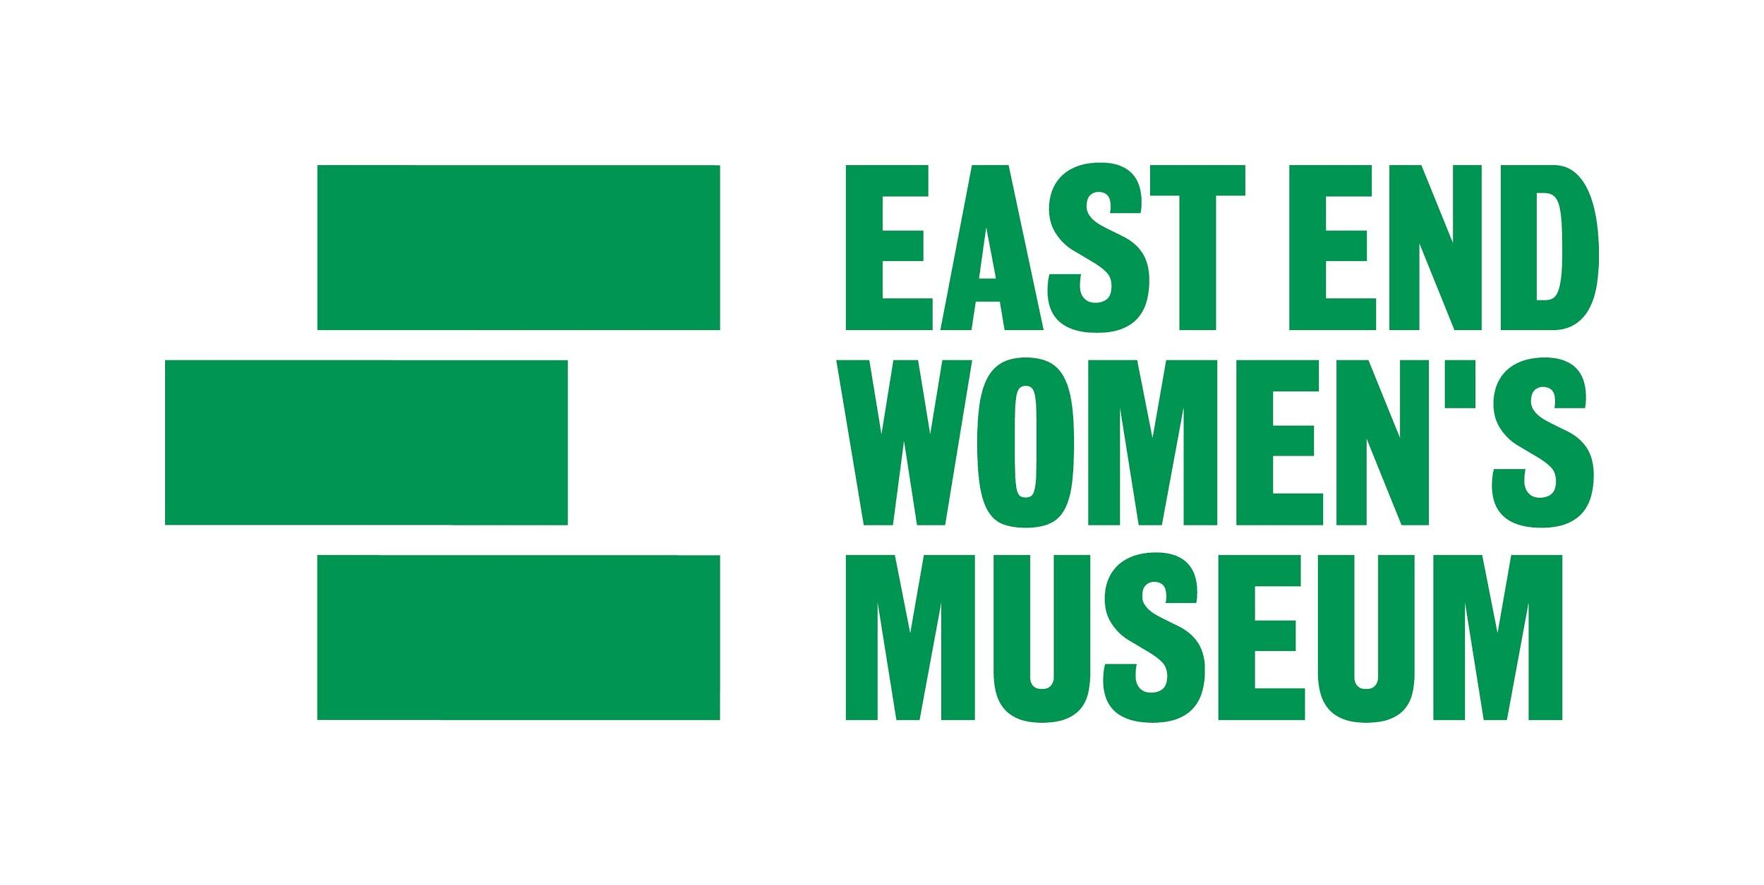

Equal opportunities monitoring form

The East End Women’s Museum is committed to ensuring that all job applicants and members of staff are treated equally, without discrimination on the grounds of gender, sexual orientation, marital or civil partner status, gender reassignment, race, colour, nationality, ethnic or national origin, religion or belief, disability or age. This form is intended to help us maintain equal opportunities best practice and identify barriers to workforce equality and diversity.

Please complete this form and return it with your application. The form will be separated from your application on receipt. The information on this form will be used for monitoring purposes only and will play no part in the recruitment process.

All questions are optional. All information supplied will stay confidential and be stored securely. It will not be placed on your personnel file. Thank you for your assistance.

About the vacancy

Please state which job you have applied for________________________________________

Where did you hear about this job (please tick all that apply)?

- EEWM e-newsletter
- Twitter
- Facebook
- Other (please state)
- Guardian Jobs
- Arts Jobs
- Charity Jobs
- University of Leicester Museum Jobs Desk
- Word of mouth
________________________________________

Gender
- Female
- Male
- Transgender
- Gender non-conforming
- Non-binary
- If you prefer to use your own term, please specify here _____________________
- Prefer not to say

Age
- 0-15 years
- 16-19 years
- 20-24 years
- 25-29 years
- 30-34 years
- 35-39 years
- 40-44 years
- 45-49 years
- 50-54 years
- 55-59 years
- 60-64 years
- 65+ years
- Prefer not to say
Ethnicity
Ethnicity is not about nationality, place of birth or citizenship. It is about the group to which you perceive you belong. Please tick the appropriate box.

White

- English
- Welsh
- Scottish
- Northern Irish
- Irish
- British
- Gypsy or Irish Traveller
- Any other White background, please state_________________________

Mixed or multiple ethnic groups

- White and Black Caribbean
- White and Black African
- White and Asian
- Any other Mixed ethnic background, please state __________________________

Asian / Asian British

- Bangladeshi
- Indian
- Pakistani
- Chinese
- Any other Asian background, please state_________________________

Black / African / Caribbean / Black British

- Black African
- Black Caribbean
- Any other Black background, please state_________________________

Other ethnic group

- Arab

- Any other, please state _____________________________

- Prefer not to say

Sexual orientation
How would you describe your sexual orientation?

- Heterosexual / straight
- Bisexual
- Gay man
- Gay woman / lesbian
- Prefer not to say

Disability
The Equality Act 2010 defines a disability as a "physical or mental impairment which has a substantial and long-term adverse effect on a person's ability to carry out normal day-to-day activities". An effect is long-term if it has lasted, or is likely to last, more than 12 months.

Are your day-to-day activities limited because of a health problem or disability which has lasted, or is expected to last, at least 12 months?

- Yes – limited a little
- Yes – limited a lot
- No
- Prefer not to say

Religion or belief
What is your religion or belief?

- No religion or belief
- Buddhist
- Christian
- Hindu
- Jewish
- Muslim
- Sikh
- Prefer not to say
- Other, please state if you wish _____________________________

Caring responsibilities
Do you have any caring responsibilities? If yes, please tick all that apply

- None
- Primary carer of a child/children (under 18)
- Primary carer of a disabled child/children (under 18)
- Primary carer of a disabled adult (18 and over)
- Primary carer of an older person
- Secondary carer (another person carries out the main caring role)
- Prefer not to say

Thank you for your assistance.

